Fall 2018

***Pikes Peak***

**Pal-*Care***

***News and Information from the Community Ethics Palliative Care Subcommittee***

Palliative Care IS Comfort Care

*Our Mission:*

*"The committee works to promote professional palliative care guidelines, to increase advanced directives awareness, and serves as advisory role to El Paso and Teller County Ethics Committee."*

<https://www.palcarenetwork.com/>

Fall time brings families together for holidays and celebrations. This will give families opportunities to have serious discussions around traditions, reflect on life memories, and discuss end of life wants and wishes. This issue provides helpful tools to make those hard topics easier to bring up.

[Aging with Dignity - Official Site](https://agingwithdignity.org/)

https://**agingwithdignity**.org

Five Wishes takes the guessing out of caring. It is a legal document that guides you through planning before a health crisis.

Helpful websites

<https://fiveinvitations.com/>

<https://deathoverdinner.org/>

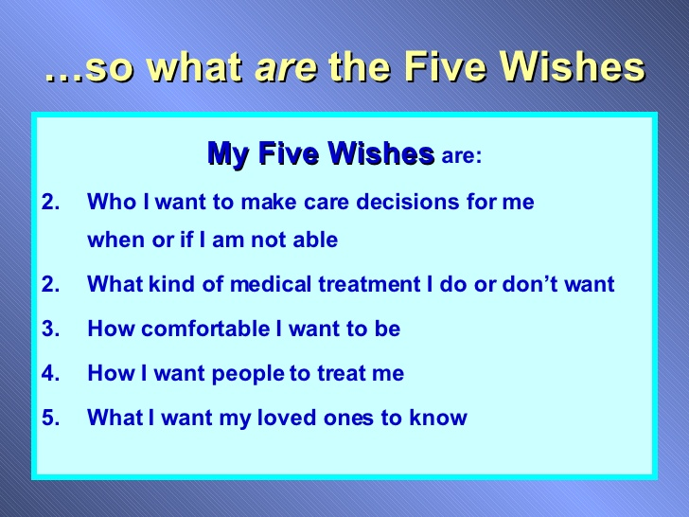

Five Wishes is a United States advance directive created by the non-profit organization Aging with Dignity. It has been described as the "living will with a heart and soul".

Co-Chairpersons:

Dr. Chris Rusky - [CHRISTOPHER.RUSKEY@UCDENVER.EDU](mailto:CHRISTOPHER.RUSKEY@UCDENVER.EDU) and Scott Bartlett - sbartlett@ppacg.org

To submit information, please contact: jnorwood@ppacg.org

***Death Wisdom-What does it mean to me?***

Kent Mathews

04/05/18

It is a wisdom we acquire from living. It is learning how to live while we are in the process of dying. It is learning to let go of what can no longer be in order to live a fuller, richer life. It is living in the present moment with what is. It is a state of being that accepts the current reality that honors the old of the past and anticipates the new of the future. It is an honest assessment of the present moment by moment by moment.

It is also a collective wisdom from the community that is openly shared and passed on to future generations. It is the acknowledgement that life is a part of death and that death is a part of life. It is a wisdom that teaches others how to embrace this reality rather than flee from it, fight it or try to ignore it.

It is the dance with our shadow self that gives depth, richness and meaning to our relationships and ourselves. It is a focus that gives meaning to our being and defies our need to do something. It doesn’t fix the problem but provides intuitive insights about the problem. It speaks the loudest in the still calm of the moment. It is the catalyst for growth and change when the doing activity of our life fails.

Death wisdom is both internal and external. External is the wisdom achieved from life events, from societies initiation rites that create liminal space. These initiation rights include but are not limited to things like divorce, bankruptcy, substance abuse, accidents, sickness/disease, unemployment, caregiving and homelessness.

Liminal space is an inner state created by an outer situation where we have to begin thinking in new ways in order to survive. It is characterized by silence, solitude, fasting, emptiness, anonymity and lack. It is a place where love and grace take on a deeper meaning. It is a place where knowledge becomes wisdom and love becomes grace.

The internal wisdom is what we feel about our mortality. It is the emotions of dealing with the challenges of limitation and debility that eventually visits the physical body in order for the spirit to be released. It is filled with uncertainty and questions. It must be shared so others can learn and then add to it.

<https://www.youtube.com/watch?v=nQ90MFMYnZg>

***Dates to remember:***

**Ethics Committee \***

First Friday every month (except holidays), 7:30 -8:30am

Followed by Behavioral Health at 9:00 am

**Pal-Care** *

Nov 30th

8– 9 am

*Area Agency Aging 14 S Chestnut St

***The Wisdom of Dying:  Can We Practice for Death?***

Sages from all times and every portion of the globe have advised us to practice for death.   Mohammed said we must “die before we die”, and Jesus taught us to “give up our lives to save them”.   What do these things mean?  Why would we want to practice for our own deaths?  Medieval Christian monks would whisper in one another’s ears, “Remember:  you will die”.   And contemporary Buddhist practitioners spend hours on their meditation cushions experiencing death in their healthy bodies.  So how can we do the same thing; how can we practice dying?

Death is not merely one final happening in a lifetime; it is not the finish line that we are forced toward as we take our final breaths.  Rather, all deaths are integral to our life – both our final, physical deaths and all the smaller deaths we experience on the way to that last event.  And we can use those smaller deaths both to help ourselves prepare for our physical dying and to help us live each of our days more abundantly.  Without allowing ourselves repeatedly to die throughout our lives, we likely will find ourselves struggling against death as our physical bodies decline.  We will resist the natural flow of life in our attempt to keep living, so that ultimately our obsession with living robs us of our ability to live fully.

Practicing for our death can look like participating in ancient rituals and ceremonies.  It may also happen through sitting on our cushion in meditation, moving our bodies in yoga class, and becoming acutely aware of the plants that are dying in our garden.  There is a wealth of guidance and support for our practicing for death.  Some of it originates in the traditions of ancestors long gone, and some of it streams toward us from the vast amounts of material found in end of life care manuals and death data from medical, psychological, sociological, and religious realms today.

Amy Agape, PhD